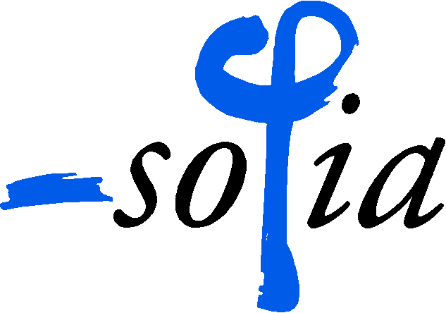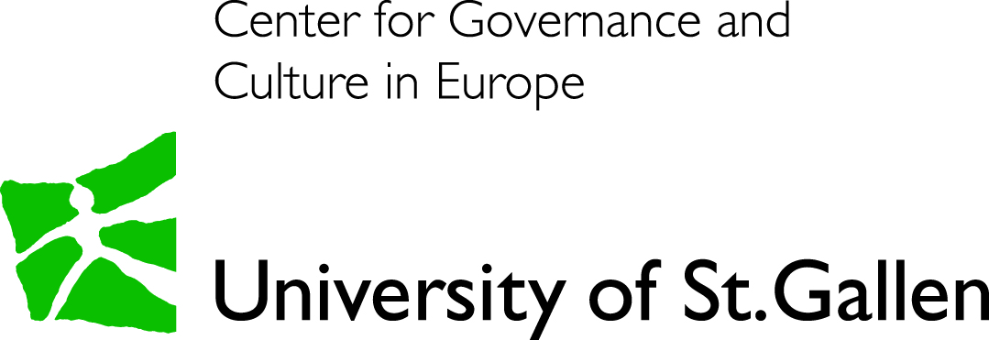

**RESEARCH NETWORK DEDICATED TO THE HISTORY OF THE MONASTIC ECONOMY**

**DOES MONASTIC ECONOMY MATTER?**

**RELIGIOUS PATTERNS OF ECONOMIC BEHAVIOR**

**(Workshop II)**

**Centre for Advanced Study Sofia (CAS)**

**9-11 November 2018**

The aim of the NETWORK dedicated to the history of the monastic economy is to nurture research in the field, namely by fostering contacts and bringing together academics from different thematic and institutional backgrounds. The key events are the three workshops held in 2017-2019. They intend to provide a forum for discussion of completed or ongoing studies covering a wide range of topics related to the monastic economy. The **comparative** approach and the **long-term relevance** are expected to take shape in the course of the debates over the case studies and the general trends in South-Eastern and Western Europe.

Hereafter we provide information concerning our

**Second** W**orkshop**

**Schedule.** The workshop will be held on **9-11 November, 2018**. The workshop will open with a Keynote speech by Assoc. Prof. Elias Kolovos (University of Crete) at **6 PM**, **on** **November 9, 2018 (Friday)**

**Venue.** The workshop will take place at the conference hall of CAS – 7B, Stefan Karadja Str., Sofia 1000 ([www.cas.bg](http://www.cas.bg/))

**Presentations.** The participants will have **20 minutes** to present their paper with a general discussion at the end of each session. A written text or a detailed handout for dissemination before/during the event is welcome. The conference hall is equipped for Power point presentations.

The proceedings will not be published. Please take into consideration, however, that by the end of the project’s three-year period (November 2019) the NETWORK will pack its research output as a scholarly journal’s guest edited issue or a volume with a collection of selected texts. The papers presented at the three workshops will be eligible for this publication.

**Languages.** The working languages of the workshop are English and French without translation from one into the other.

**Accommodation and Travel arrangements**

* We have booked for each participant the stay for two nights (November 9 and 10) in a single room in Diter Hotel ([https://diterhotel.com](https://diterhotel.com/)) located within 10 minutes walking distance to the Centre for Advanced Study Sofia ([www.cas.bg](http://www.cas.bg/)) where discussion will be held.
* CAS will book your flights in advance. **You are expected to arrive in Sofia on November 9, 2018 (Friday) before the opening of the workshop and depart on the afternoon/evening of November 11, 2018 (Sunday) or the next day on November 12, 2018 (Monday).** Please, let us know not later than September 25, 2018 your flight preference (the cheaper option) in order to proceed with the booking.
* We will reimburse the tickets of the participants using land transportation (in your own country or for the international trip to Bulgaria) upon arrival in Sofia.

Ass. Prof. Roumen Avramov Dimiter Dimov

Permanent Fellow CAS Sofia

CAS Sofia Contact Person

Convener of the workshop [dimov@cas.bg](mailto:dimov@cas.bg)

[avramov@cas.bg](mailto:avramov@cas.bg)